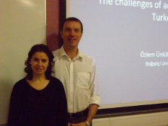
Dr. Ünlühisarcıklı with Dr. Ralf St. Clair of the Faculty of Education UG

