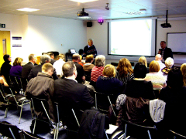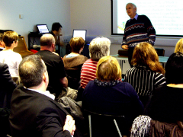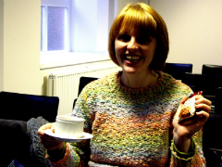‎
(Apart from the photograph of Professor Jarvis and that of Peter being introduced to the Seminar attendees by Professor Mike Osborne, Director of CR&DALL, we have added a special photograph of CR&DALL's 1000th 'customer' for 2010 - and always the first to arrive! As the tea and biscuits are free at each Seminar in any case, no additional bribery was supplied!)

